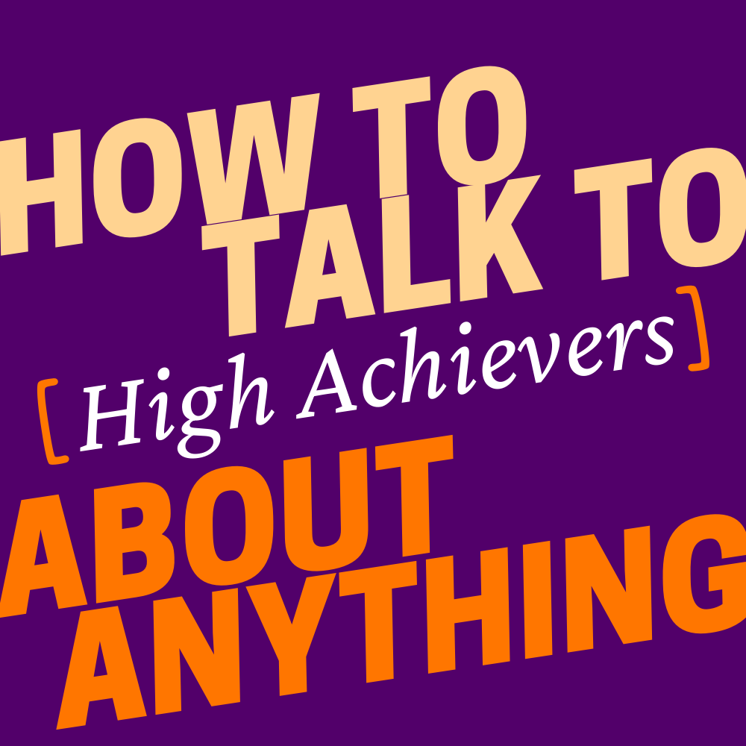
Feeling Inadequate Because Her Clients Aren't Making Progress
Keyonna is a mental health practitioner who loves her work. But when she doesn’t see the client progress she expects, she questions her own abilities. Stevon and Juleyka discuss strategies for remaining clear-eyed about your accomplishments.
__________________________________________________________________________________
Clip: Goals are places we want to get. Things that we want to achieve and accomplish. The distorted parts, or the irrational beliefs, come in when we hold the world or the universe to a place of how that's supposed to happen. So the goals are the “what”, and then, we get really caught up, or high achievers get really caught up, in the “how.”.
Stevon Lewis: What's up, everybody? Welcome to How to Talk to High Achievers About Anything. I'm Stevon Lewis, a licensed psychotherapist. Today, we're going to discuss that thing high achievers are so good at doing: feeling like their results define them, who they are and their worth. But before we start, I'd like to welcome Juleyka Lantigua, the creator of our show, who's joining me today. Hi Juleyka, how are you?
Lantigua: Happy to be here, as always, man. It's so good to learn from you and just spend time with you.
Lewis: Let's do this.
Our guest today is Keyonna. Keyonna is a mental health practitioner and emotional intelligence coach. She's really devoted to the clients she works with, but when her clients don't get the outcomes they want, she can't help but take their lack of results and progress personally. So much so that she begins to question how effective or valuable her methods and advice really are. Let's get into it.
Keyonna: My name is Keyonna Monroe, and I am a neurolinguistic programming practitioner and emotional intelligence coach. I help people understand the process of thought, and understand the emotions that they have, how they work, and how they impact their lives on a day-to-day basis.
I started out as a journalist, and I decided to hop into the field of mental health and emotional wellness. I have two organizations that I work for, one specifically for adults and corporations, individuals, the Life Matters Project, and the other is the Pretty 2 Me Foundation, which is my nonprofit organization for young girls.
Keyonna: So some of the challenge that I have is when I am working with clients, whether it's the adults or whether it's my young students, I tend to recommend a lot of homework and tips and tools that they can use that will help them in their day-to-day, and things that they can apply into their life as they're going through this journey of healing.
A lot of times I work with teens that are considered troubled teens, so they're trafficking survivors, sexual assault or domestic violence survivors, and I see myself in every young girl that I work with being a trafficking survivor myself. And I always felt like with everything that I've been through and the trials and tribulations that I've had to conquer, that these tips and tools that I'm giving others, if they would work for me, they would work for anyone. So I actually take it very personally when it doesn't seem to work for them.
There was one time, one particular client that I had, she was having some difficulty kind of standing up to her mom and putting up healthy boundaries, because she really wanted a relationship with her mother and she loved her mother, but no matter how much she tried, she kind of went into people-pleasing mode, and the advice that I gave her, she actually was afraid to take that advice and use it.
She basically said, "I don't know if I could do the boundaries. I don't know if I could tell my mom no. I don't know if I could use my voice and stand up to her." And so no matter how many times we went around different angles, she didn't want to necessarily apply them out of her own fear. And she felt really, really defeated.
Keyonna: And so it really was like a gut punch to me a little bit that I really wanted to help someone that matters to me, because all my clients matter to me. And I took it very personally that nothing seemed to work that she was comfortable with.
And I internalized that as a personal failure, feeling like maybe I didn't get enough education, maybe I should relearn how to have conversations or harder conversations. I really started to kind of pick myself apart, thinking that there was something wrong with me because I wasn't able to help my client.
For the most part, I bring a lot of relatability and my own personal side of myself into my client sessions, and so it tends to work, but when it doesn't, it makes me feel as if they are disconnected to what I'm trying to do. And for me, it's kind of like if I'm not willing to go the extra mile to make sure that they get it and make sure that they get those results, it makes me question if I'm in the right field.
Lewis: Keyonna, thank you so much for joining us and sharing your experience.
Lantigua: All right, Stevon, what did you make of this one? Because it was intense.
Lewis: Yeah, so Keyonna's story is interesting. She's been able to overcome and achieve a lot, despite kind of where she started. And what really kind of connected to me was this thing I see in high achievers, where they take responsibility for the outcomes that they tell themselves they're supposed to get. What we call that in the field of counseling psychology, is irrational beliefs.
Some cognitive behavioral therapists might refer to them as distorted thinking or cognitive distortions, all just a really fancy way to say that a person is holding on to rules about how the world is supposed to operate and the outcomes they're supposed to get, even when the world is not operating that way and giving them what they want.
Lantigua: Okay, but I have to push back on that, because what's the difference between that and goals?
Lewis: Goals are places we want to get, things that we want to achieve and accomplish. The distorted part, or the irrational beliefs, come in when we hold the world or the universe to a place of how that's supposed to happen. So the goals are the ‘what’, and then we get really caught up, or high achievers get really caught up, in the ‘how’.
Lantigua: Wow, that is such a good explanation for that, because I think a lot of us get those mixed up the ‘wha’” and the ‘how.’ How do you see this play out in your practice, and how do you help the overachievers to learn that difference and practice that difference?
Lewis: So it shows up for me in my practice and the folks I work with, when they are not as happy or satisfied about what they've accomplished. So for myself listening to their stories and listening to Keyonna, I'm like, "Oh, you're doing amazing things. You've accomplished a lot. You're helping people."
And the tendency is to say, "Well, this didn't happen the way I thought it would or the outcome I was supposed to get in the way that I hoped it would happen." How fast or how easy it was supposed to happen, they're stuck on that part. And so they diminish their joy or satisfaction that we would expect to see around the thing that they've accomplished.
Lewis: More on this after this short break.
Lewis: So Keyonna has helped probably tons of people, and it's the ones that she felt like, "Well, they didn't get the same outcomes I got based on what worked for me," that she holds on to.
Lantigua: Okay. But I think we have to be honest and talk about something that's really important, which is that she has a shared traumatic experience with some of the people that she works with.
She herself is a survivor of trafficking, and so she is not only professionally committed, but she's also on a very personal level, committed and connected. So let's talk a little bit about, how do we create distance between our personal experience which might be relevant to the work that we're doing, and our client's experience?
Lewis: That is a really good distinction to make. Even for myself, when I'm working with someone whose story mirrors mine or has elements that are similar to what I've experienced, whether it be just being a black male or first person to go to college in the family, it's hard for me to separate out and say that, "Well, I'm different from this other person, because so much of what we've gone through is shared." And I think the key is to remember that there's a lot that goes into how we got to where we are today.
And I think sometimes in our own personal journey we dismiss or minimize or forget all the things that had to happen for us, whether we call it chance, or the luck of the universe, or favor that had to happen in the way that it did for us to get the outcomes we got. And just because it happened for us that way doesn't mean that it's going to translate well for somebody else who's going through something similar.
Lantigua: That takes a lot of practice, I imagine.
Lewis: Absolutely. It's not easy. You have to be relentless, because again, what we tell ourselves is, "This worked for me, this should work for the other person as well."
Lantigua: I want to talk about shame, because it's something that I'm learning a lot about in my own healing journey post my divorce, and how paralyzing shame can be. And there's a line in Keyonna's story that I was like, "Shame," is what I wrote as I was taking notes and she says, "I took it very personally that nothing seemed to work. I internalized that as a personal failure."
Lewis: So that is really hard to hear, and it hurts my heart to know that Keyonna is taking on the burden of responsibility for saving others. If others aren't doing well, it's a personal failure for her. She's not done her job. That's going to be a lot of disappointment she's going to have to contend with in life. It's a noble goal, but also we have to factor in that some people will not be able to be saved no matter how hard she tries.
In my practice, I know that everyone that I accept into my practice to work with me, I want them to be better. That doesn't always happen with Stevon. But also I think of myself as a step or a stop along the journey, and so that I just got to do my part to kind of maybe get them to the next place.
Lantigua: Okay. Actually, I want to talk about that a little bit, because Keyonna says that she often feels like there must be something else that she could have tried. That there's an extra mile she could have walked with her clients. How do we deal with that sensation, and then how do we reach out for help?
Lewis: That is a tough one, because what she's saying, what Keyonna's saying when she's, what I call, being really hard on herself, "There's something else I could have done." There's a belief she's holding onto that her skillset and abilities can help everyone, and that she can get good outcomes for everyone. Just because she's human, I know that that's not possible.
And so she's got to have some compassion and favor for herself. And not to judge herself or define herself based on that is really, really difficult. My goal for her is to know that it takes more than one person. I think she also can benefit from having a community of strong leaders that are dedicated to doing this work, so as a team, they can go through and make stuff happen where her skillset ends, someone else's might begin.
Lantigua: I love that idea. It's sort of like in a relay race, you're handing the baton.
Lewis: It is. I passed the baton, and that person that carries the baton or gets it from me needs to run really hard to their next stop.
Lantigua: Okay. I love that. I want to talk about her job title a little bit. It's neuro linguistic programming practitioner.
Lewis: It's a mouthful.
Lantigua: And to me, it's basically the stories that we tell ourselves. And so let's set aside Keyonna being a professional, a practitioner, and let's talk about high achievers, because we tell ourselves some crazy ish sometimes.
Lewis: It's not sometimes, it's all the time. Yes, you are crafting and concocting these narratives that suggest maybe you can do all the things because that's what you've pushed yourself or purposed yourself to do.
Lantigua: So what should we be telling ourselves?
Lewis: I like to get the high achievers that I work with to temper their expectations, adopt a narrative that sounds something like this: I'm going to work really hard, and I'm going to give it the best I can with every person that I work with, and my hope is that they will also be putting in work and they will get good outcomes, or they will leave better than when they met me.
And I have to also tell myself that I don't know what that will look like. So I can't say how great that change might be, or how significant, but I do know that hopefully it'll be better.
Lantigua: So we basically have to remain optimistic about the outcomes, but realistic that until we are going through that journey by ourselves with a client in whatever context, we won't really know what the possible results are.
Lewis: You know that that is a really succinct way to say it. I like it.
Lantigua: I'm like your translator.
Lewis: You are. You speak Stevon so well.
Lantigua: I'm going to take that. I'm just going to take that and roll with it.
Lewis: Thank you, Juleyka, for joining me today.

Lewis: It makes me really proud when I see high achievers like Keyonna achieving on their own terms, by being passionate about the work they do, being open to trying different things to help those they serve without taking responsibility for their outcomes, and focusing on what they are accomplishing instead of how it's being accomplished.
And that's a wrap. Thank you so much for listening to How to Talk to [High Achievers] about Anything. We want you to be a part of our show.
We want to hear about your successes and challenges, your sacrifices and celebrations, and what's ahead on the journey for you. Send our Producer Virginia an email and we'll get your story on the show. She's at virginia@lwcstudios.com.
How to Talk to [High Achievers] about Anything is an original production of LWC Studios. Our show is produced by Virginia Lora, Tren Lightburn mixed this episode, Juleyka Lantigua is the Creator and Executive Producer. I'm Stevon Lewis.
On Twitter and Instagram, we're @Tal toAchievers. Bye, everybody.

CITATION:
Lewis, Stevon, host. “Feeling Inadequate Because Her Clients Aren't Making Progress” How to Talk to [High Achievers] about Anything, LWC Studios., September 18, 2023. Talktohighachievers.com.
Produced by:

